AWS Assignment 5

Task 1
Launch below infrastructure in your aws account using ansible's aws cloud modules
- create a key pair using ansible
- create one security group that would allow you to ssh into the instance
- using the key that you created, launch an instance in default vpc of N.virginia region with tags of your choice
Solution:

- Configure aws iam user into base system
- Created playbook (awsansible.yml) for creating key pair, launching ec2, creating security group
- Run the ansible playbook using:
ansible-playbook awsansible.yml

Link:
https://s3.amazonaws.com/ansibleplaybook/awsansible.yml
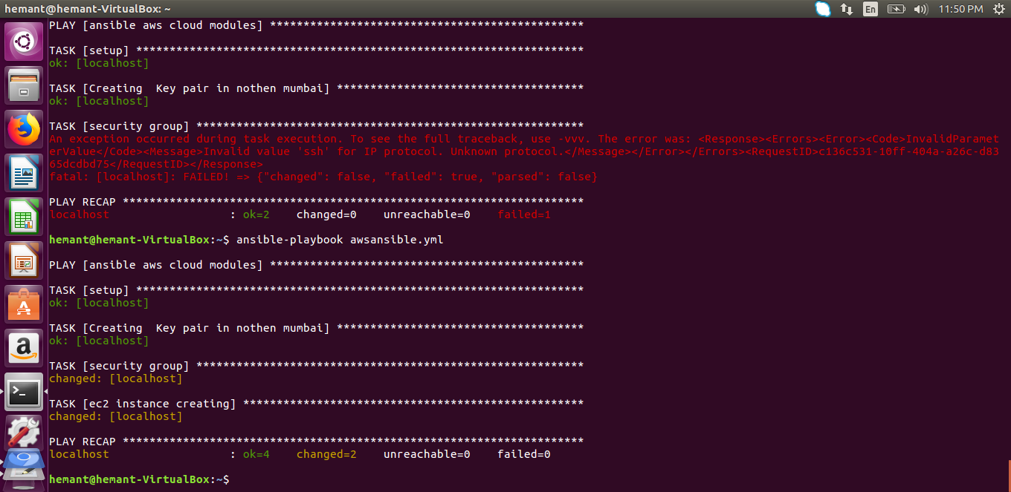
- It creates and launches an instance
